CS 6890 iOS App Design Summer 2013
Dr. Cannon

Assignment #1 In Case of Emergency (ICE)

Develop an iPhone app to provide a finder with identification info in case of emergency. First responders are taught to look for an app or contact named “ICE”, so that should be the icon title.

The app should toggle between two displays of info: The first display should include a name, phone number, address, and emergency phone number. When the MEDICAL button is pressed, the display should change to provide a doctor name and phone number along with important medical information. Pressing the ID button should return to the first display.

For example:

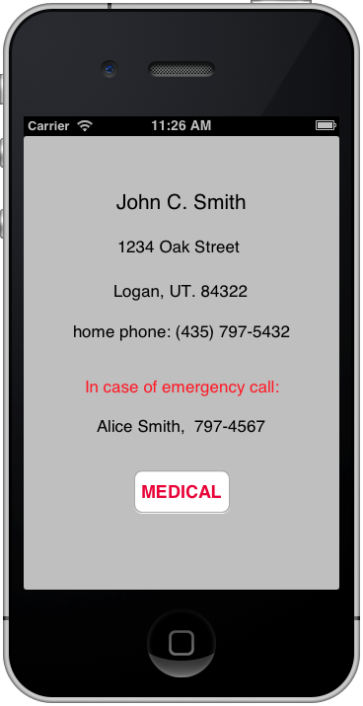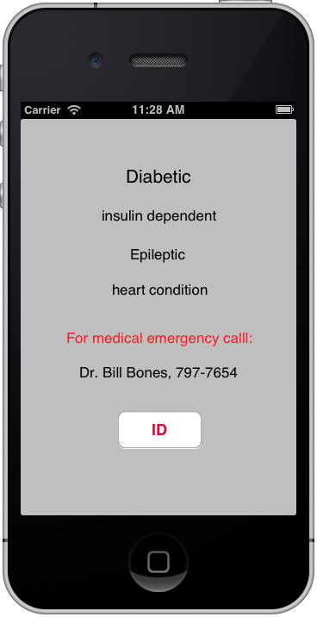

You need not worry about which screen displays first. An icon image is available on Canvas.

